analysis report for ms access fundamentalS course
Anna Leach
November 2, 2016
Autumn 2016: ESETEC 6278 – Instructional design
Dr. Stucky-Mickell

The Office of Enrollment Services - Analysis and Reporting (OESAR) holds Data Acquisition and Analysis (DAA) training monthly for the Ohio State University (OSU) Operational Data Store (ODS) Power Users. Power Users are persons within the university departments and colleges that have a need for data to make decisions about operational procedures or policies beyond the record level information that can be found in the Student Information System (SIS). The Power Users are adult learners that are new to the university or a role that requires data. The participants vary greatly in their data and querying tool experience. DAA’s objective is to demonstrate key tables in the ODS and review key criterion. DAA is an 8-hour training, facilitated in person and presented in MS Access. For those that are not familiar with MS Access, the hurdle of learning the tool can distract them from learning data content. There is not enough time in the DAA training to allow for MS Access review. There are MS Access tutorials available on-line, but none contain the specific needs that would complement the DAA training because they are either too broad and cover unnecessary items or too narrow and cover only one component when more is needed. By providing an online course, titled MS Access Fundamentals, that is self-paced and can be taken prior to attending the in-person DAA training, the students have the opportunity to become familiar with MS Access vocabulary and functions. Therefore, allowing the user to focus on key tables and criterion instead of how to navigate the tool. The MS Access Fundamentals course could be utilized after the DAA training as a refresher for current data needs. The course could also be used as a training tool for those that want to learn MS Access basic for local data use.

Needs Analysis

The specific needs that will be addressed by this training are comparative, felt, expressed and future. People that are in the Power Users group at OSU are either current "data" people or on their way to becoming the "data" people of their department or college. For those that attend the DAA training, their data querying tool experiences vary. Data querying tools include SQL tools, MS Access, SAS, Tableau and many more. Based on personal experience having facilitated the DAA training sessions in the past, people are less likely to have had querying tool experience as they are new to the position or need for data.

Comparative Needs
By comparison, there are "data" people within the university that have been Power Users for many years that have become comfortable querying data using MS Access. The intention of this training would be to get people to a position of comfort with MS Access so that they may explore the data as well as the more experienced Power Users.

Felt Needs
During several trainings and post training, attendees have explained that they had difficulty following along and missed portions of valuable information. The said that they didn’t know how to open a table, or make a join and spent time focusing on how to figure that component out and fell behind. Some have shared their frustrations during class either verbally or by not participating in the hands-on segment of the course. If I had the opportunity to interview or survey previous participants about their comfort level with MS Access, I feel confident that the responses would indicate that a majority of participants found the MS Access use as a hurdle.

Expressed Needs
Several students have reached out to my colleagues and I requesting assistance with building queries in MS Access. We have set up several workshops to help people trouble shoot their issues with not just the data, but correctly setting up MS Access. For example, participants had trouble understanding how tables are linked and were adding too many links or tables to a query. Lastly, we have had people send us their databases so that we can sleuth out issues and send them corrected versions.

Anticipated/Future Needs
The students that attend the DAA trainings are typically new to their role. MS Access's uses can expand beyond querying the ODS. It can be used to track information such as class enrollments, attendance, work flow management, or even an inventory. It is also a tool that could be added to a person's repository and boost resume appeal.

Measure Priority
We will want to get a sense of comfort level with MS Access prior to the training, experience when following along during the hands-on portion of the training, ability to use material learned immediately after training and get opinions on the value of a prerequisite MS Access course. To do this, a survey will be sent to a random population of Power User DAA alumni. Currently, I do not know the total number of people that have taken the DAA training, but I do know how to get the list of participants and I would approximate the volume to be around 500. After weeding out those that are no longer part of the university, I would like to take a stratified random sample of the population based on class attendance. The strata would be based on the year starting from 2009 and ending with 2016. The methodology is based on the fact that OSU changed system in 2009 and that is when the DAA trainings began. Furthermore, there were several iterations of the training as it morphed over time. Additionally, there was a switch from quarters to semester in 2013 and that also affected trainings. I would like to use a survey tool like Qualtrics and allow for several open-ended responses. I would like surveys to remain anonymous. This will allow attendees to respond in an unbiased manner.

Conclusion of Needs Analysis
The online Fundamentals of Access for DAA Training course is needed to provide a guided overview of basic MS Access functionality and definitions. The DAA training is conducting using MS Access and those without a fundamental understanding of query tools will fall behind in training and might become frustrated with their lack of understanding. It is difficult for the trainer to hold the audience’s attention if they are overloaded with too many stimuli, which would include trying to learn a new tool on top of learning how to use the ODS. Also, those that attend this training and then the DAA training will have had an opportunity to rehearse the MS Access functionality and vocabulary and then there is a better chance that they will learn the material. Also, the course will be based on the users discretion and not be a requirement to attend DAA. Lastly, the course can be utilized by Power Users after DAA as a job aid for using MS Access.

Goal Analysis

The goal of the training is to provide the DAA Power Users the following:
- Provide an overview of MS Access including: desktop icon and 5 tool bar tabs: File, Home, Create, External Data, and Database Tools.
- Review the File tab that allows the database to be saved and how to open a saved database.
- Explain the two key components of the External Data and Database Tools tabs that are needed to connect to the ODS. Review the process to install the ODS table linker on the Database Tools tab. Review the Linked Table Manager function on the External Data tab. Briefly overview ways to connect the MS Access database to other tools such as Excel and another MS Access databases.
- Step through the two most utilized components of the Create tab: Query Design and Query Wizard. Query Wizard has a step by step interface. For the training, we will review the duplicate query. Query Design has several components that need addressed and the bulk of the training will be spent on this component. First, discussion of selecting a table from the Show Table pop-up or dropping and dragging a table from the table list. Second, selecting fields from table and running the query. Next, we will discuss the six query types: Select, Make Table, Append, Update, Crosstab, and Delete. The focus will remain on the Select and Make Table queries, but all will be explained. Here we will demonstrate saving a query and using a local table. The next step will be to build a make table query that uses criteria. Lastly, we will discuss the group by process.
- Explain the views on the Home tab based on previously made and saved queries

Learner Analysis

General Characteristics
The population will consist of university associates, either from departments or colleges. They will be adult learners and generally over the age of 22. Their work experience will vary. The pool of participants will be any staff members in the Executive, Professional, Clerical, or Paraprofessional role. According to the Ohio State University Human Resources Data on Faculty and Staff Diversity, 30% of these roles are male and 70% are female. The breakdown by ethnicity is:
Ethnicity | Percentage
African American | 9%
Asian | 6%
American Indian | <1%
Hispanic | 2%
White | 78%
Pacific Islander | <1%
Unknown | 3%
Two or More Races | 1%

Specific Entry Characteristics
Most attendees have a general knowledge of university business process and the Student Information System (SIS) as either advisors or having worked in the operational and administrative side of the university like Student Services Center or University Bursar's Office or the Office of the University Registrar. Most attendees have little experience with data but are familiar with reporting and data-driven decision making. Power Users seek the training when they are trying to gather more information therefore the majority of attendees have a specific data goal in mind when they come to class.

Academic Information
It is assumed that a majority of those attending the training will have received a baccalaureate degree. It is not assumed that all attendees have been exposed to the data analyst process or MS Access. Our experience shows that about 50% have had data experience and 50% have had some exposure to MS Access but very few have both or are experts in either area.

Personal and Social Characteristics
Again, most Power Users will have university business process and SIS experience. The attitude of attendees can vary based on two components: voluntary or forced attendance and perception of complexity. Those that attend the training because they have been forced into a new role or told they have to attend training, tend not to be as enthusiastic. They also tend to follow along during the hands on component of the class but do not explore. Also, they tend to not stay or return for the workshop component of the course which is held for an hour at the end of the class to allow participants to ask questions or get help. Those that are voluntarily attending are typically excited to dive into the data and explore the outcomes. They are engaged and ask many questions. Secondly, is perception of complexity. There are some attends that assume they will not be successful in the class because the data is too robust and confusing or they do not know MS Access or any data mining tool and feel extremely uncomfortable.

Cultural and Ethnic Considerations
Those that are deficient in data analysis or analysis tools would feel out of place and not be able to following along in DAA training. These people would benefit the most from the MS Access prerequisite training as it would introduce them to the tool and allow them to gain a little comfort in navigation. The MS Access training will need to not select one specific college as the data example and should select from different campus and colleges to keep any one college from feeling under examination.

Special Needs and “Able-ness” Considerations
The MS Access training would be held on=line and self-paced. It would have voice over, but for someone that is visually impaired it may influence learning. Also, having the training in an online format may cause issues for those that are not comfortable in an online learning environment. Careful selection of the right online tool and keeping information clear will be critical.

Miscellaneous Considerations
Because this is going to be created for the university community, we will have to be careful not to expose anything on screen, during the training that would be considered confidential or proprietary information from the university, college or student.

Contextual Analysis

Orienting Context
The MS Access course will be a voluntary prerequisite to the DAA training. The training will be offered online as a self-paced interactive course. To assist the trainee in determining their need or lack of need, a series of question will be asked in the invitation to DAA training. These questions will ask specific questions about data analysis and data analysis tool experience. Based on their responses, OESAR will either highly recommend, recommend, or do not deem it necessary that they participate in the online MS Access course. It will ultimately be up to the participant to decide if they would like to take the MS Access Fundamentals course. Students may not be motivated to take the course if they are being required to attend DAA training or do not feel that the MS Access Fundamentals course will benefit them. By attending the MS Access course the learner will gain the skills necessary to attend the DAA training and continue exploring the data well after the training has ended. Those that have had prior data analysis experience or regularly use MS Access would not find this training useful. Those that have not had prior experience should find the information beneficial and be able to utilize the skills acquired immediately. They will also be able to refer back to the training as they progress and improve in their analysis.

Instructional Context
The training will be provided online through Buckeye Learn. It will consist of a series of segments and include video demonstrations with voice over when appropriate. The course will have interactive components that allow the user to practice what was just taught. This will also allow the users to evaluate their knowledge gained and retained. It will also contain job aids at the end of each section that review what was covered. These job aids can be printed and saved right from the training for easy access. The learner will also be encouraged to bring the job aids to the DAA training to assist them during the training and workshop. This will also improve the learner’s retention. It will be self-paced. They will most likely be using their work computers but can use their personal computer. Due to videos and interactive nature of the course, they will need a reliable, well-functioning computer and high speed internet.

Transfer Context
It will be recommended that the user complete the MS Access course within one week of attending the DAA training. This will ensure that the information is "fresh" in their minds. Because the DAA training is held in MS Access, the user will be exposed to the same screens and functionality in the DAA training as they were in the online MS Access course. They will also have the opportunity at the end of the DAA training to get any clarification on MS Access they may need by talking with the DAA instructor. The DAA instructor can work with them to correct or review the MS Access tool in real-time. MS Access will then be the primary tool used to query data after the DAA training. The participants will therefore utilize what was learned in MS Access fundamentals and reiterated in the DAA training. They can also refer back to the job aids, course, or DAA instructors if they run into issues with MS Access functionality.

Data Collection and Analysis Plan
One method would be to survey previous DAA trainees to gather input on what MS Access information would have best suited their needs for DAA training or post-DAA training data gathering needs. Depending on the number of attendees since 2009, it would be appropriate to gather a stratified random sample based on year of attendance and place of work. We need to stratify by year of attendance for multiple reasons. First, OSU went through 2 significant system changes. In 2009, OSU changed from a legacy system to People Soft and second, OSU changed from a quarter based year to semesters. Second, as time progresses, those who took the training years ago and continued to use MS Access to query data will have a different perspective than those that took it this past year. Lastly, due to these changes, class attendance and size of classes fluctuated from a full room to 1 or 2 attendees. Therefore, the reaction of DAA training with respect to MS Access may vary by year. During the selection, the participants current OSU employment status will need to be considered as some of the employees may have retired or left OSU. Also, some attendees took the training more than one time, so duplicates will need to be handle by selecting the max year of attendance.

Another option is to survey students that take the MS Access Fundamentals course after the DAA training is complete to see what they thought was beneficial and what was not with respect to the MS Access Fundamentals course. With this feedback, we could adjust the training to really get to the core of users querying tool needs.
Challenges and Benefits
The learners for the MS Access training will vary in experience, with querying tools, university business process and university data.

Task Analysis

Content Type
Facts and procedures will be the covered content types.

A fact is “an arbitrary association between two things” (Morrison, p.75). Here is a list of the facts that will be covered in the course:
- What is MS Access
- The MS Access icon
- The MS Access file extension
- Review the screen layout: tool bar, left area containing Access Objects, and right area containing Query Workspace.
- Within the Access Objects, define:
- Table
- Query
- Macro
- Within the query workspace define the different types of links between tables, table keys, and define the query properties of: Field, Table, Total, Show, and Criteria.

A procedure “is an ordered sequence of steps a learner must take to complete a task” (Morrison, p. 76). Here is a list of procedures that will be covered in the course:
- Open MS Access.
- Save the database.
- Run an existing query.
- Create a new query.
- Create a link between tables.
- Add criteria to a query.
- Run a query.
- Run a Macro.
- Open a Table.
- Close the database.

Task Analysis Technique
The methods used to perform the task analysis will be topic analysis and procedural analysis. A topic analysis is used to “define the facts, concepts, principles, and rules that will make up the final instruction” (Morrison. p.77). The primary purpose of the course is to provide the DAA attendee with the vocabulary and basic MS Access processes that they will need to successfully attend the DAA course. Attendees will gain knowledge as we define each component of the MS Access tool and then synthesis it by stepping through the procedures that each components uses to get the final results. Therefore, it is necessary to do a procedural analysis as well to ensure that the attendee is aware of how to use each component during the hands-on component of the course. The difficulty with using only the topic analysis or only the procedural analysis for this course is that both are needed to truly understand. Just knowing what the red exclamation point is will be enough for the user to following along in the class when the instructor says, “Click on the red exclamation point to run your query”. But just knowing what a table is will not help you when the instructor tells the group to create a new query. It is necessary to understand what a table is in order to create a query. It is necessary to know what each type of query does. It is necessary to know how to tie those facts together to create a query.

Topic Analysis
The topic analysis will review the key vocabulary used when referencing MS Access in the DAA training. Understanding what the tool is and recognizing its icons on the screen will be beneficial for the DAA attendee while trying to following along with the instructor.
- What is MS Access:
- It is a querying tool that uses relational databases. It connects to the ODS (day old data from the ODS) through the add-in ODBC connection.
- The icon looks like this: 
- The file extension is “accdb”
- Layout: 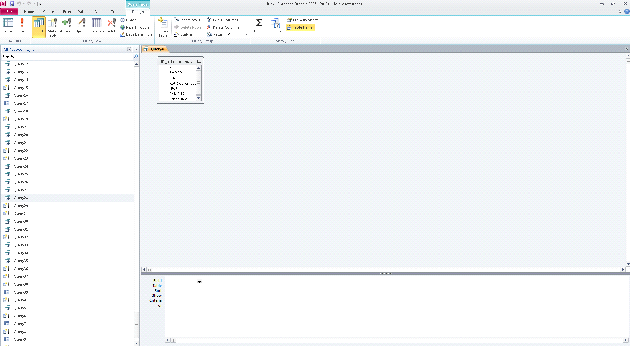
- The tool bar is located at the top of the page once MS Access is open.
- File: Save – this allows use to save the database to your choice of location and with your choice of naming convention. Please note it is best practice to save on a secure, backed up network.
- 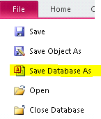
- Database Tools: Add-ins
- Create: Query Design – the component allows the user to create a new query. It will open a new tab in the tool bar that has several different types of queries.
- 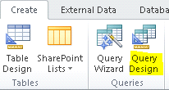
- Design: View, Run, Query Type
- 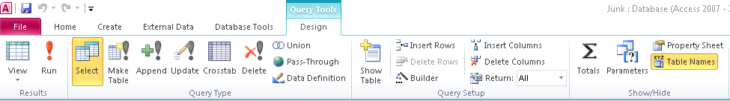
- View – allows the user to switch between datasheet view and query design by clicking on the drop down arrow.  Datasheet view is similar to a table which lists out multiple columns and rows of information. Query design is the Query Workspace where you can manipulate the query logic.
- Run – allows the user to execute the query.
- Query Type:
- Select Query – a query that will rerun the logic and not create a local table each time it is Run. 
- Make Table – a query that will make a local table in the database: 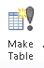
- Home: Filter and Sort – when using a table and wanting to analyze the data, the filter and sort functions can be used. These allow the user to apply criteria to the table to gather specific information or sort the information as needed.
- 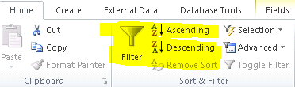

- Access Objects that will be covered:
- Table – A table will either be a linked table or a local table. Tables linked to the ODS will be a globe: Tables that are not will look like a grid: Linked tables will have an arrow icon before the table icon:. The local tables will not.
- Query – A query will be Select, Make Table, or Crosstab. A select query will look like this: A make table will look like this: and a Crosstab query will look like this:
- Macro – A series of code written to run a series of queries in a specified order. Its icon looks like this:
- The query workspace is where the magic happens. The query workspace is where tables are added and joined and criteria added. At the bottom of the query in design view there are 5 pieces of information:
- 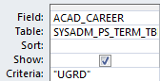
- Field – is the field name in the table
- Table – is the table that the field came from
- Sort – is used if the information should be sorted ascending or descending. If it does not need sorted, the field will be blank.
- Show – is used to indicate if the field should be shown in the final results. If the box is checked then the results will be displayed, if not checked then the results will not be displayed.
- Criteria – here the user will put in specific criteria to limit the results. For example, here the results will only be undergraduate records because the logic is limited to a value of “UGRD” in the ACAD_CAREER field of the SYSTEM_PS_TERM_TBL.

Procedural Analysis
The procedures that need to be taught are the basic operational functions in MS Access that are used in the DAA training. The process is cognitive in nature and relies on knowledge gained from fact review, comprehension of relationships between items like tables and queries and application of the knowledge gained.
- To open MS Access, there are three options:
- Search for MS Access in the list of programs on your PC.
- Click on the Windows icon
- In “Search programs and files” type Access
- Click on the Access tab
- Create a new MS Access database or open an existing one by navigating to a saved database.
- Double click on the MS Access icon.
- Right click on the MS Access icon and select Open.
- To save the database, the user must go to the File tab and click on Save As. They will then be prompted to save the file to a location and name the file.
- To run a query that already exists, the user can:
- Double click on the query icon.
- Right click on the query icon, select Design View, and then click on the red exclamation mark, labeled Run, in the toolbar under the Design tab.
- Ensure the query is selected, it will be highlighted in grey, and click on the red exclamation mark in the toolbar under the Design tab.
- To create a new query, the user will go to the Design tab in the tool bar and select the query type. The user will then select the tables by either dragging them into the workspace or selecting from the Table pop-up. The user will save the query.
- To create a link between tables, drag the mouse between two fields while holding down the left mouse button. To create a directed join, double click on the link and select the direction of the join.
- To add criteria to a query, place criteria in the criteria row.
- To run a query, select the red exclamation mark.
- To run a Macro, double click on the icon.
- To open a Table, double click on the icon.
- To close the database, click on the X in the upper right hand corner.

Data Collection and Analysis Plan
In order to determine if the necessary steps are covered in the course, I would need to interview the two DAA trainers and their supervisor. The DAA course is conducted by two employees in the Enrollment Services – Analysis and Reporting (OESAR) department. Their supervisor is the data steward for student records at OSU. By speaking with them and sharing the facts and procedures that I think should be covered in the MS Access Fundamentals Course, I can ensure that I get feedback and input from the subject matter experts and cover all the necessary items to make this course successful. It will also be critical to attend the DAA training or review the DAA training materials to gather data on each component of MS Access that is used or discussed. I can use this data to compare it to the facts listed to ensure that the majority of vocabulary used is covered.

Learning Objectives
Ideally the user will be able to complete the following learning objectives before or on the day of their DAA training:
- Open an MS Access database, Table, and Query.
- Describe the difference between a make table query and select query.
- Create a simple query consisting of at least 2 tables, one join, and one criterion.
Challenges and Benefits
It will be critical to have this course include interactive and engaging components that have the user do what was just learned. Due to data and access to MS Access restraints, the application of learning will have to remain within the course. The benefit to this is that as long as the user has a working computer and internet access, they will be able to run through the training without access to data or the MS Access tool.

References

Hr.osu.edu. (2015, September 30). Retrieved November 2, 2016, from https://hr.osu.edu/wp-content/uploads/diversity-university-summary-2015.pdf

Morrison, G.R., Ross, S.M., & Kemp, J. E. (2004). Designing effective instruction. Hoboken, NJ: J. Wiley & Sons

